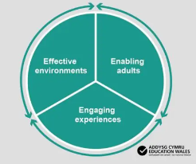

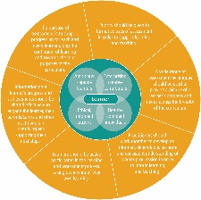

Teaching and Learning
2. To audit, adapt and refine indoor classroom environments to ensure they are effective for all learners and actively enable high-quality learning opportunities.
Lead: Mrs D Bradley

Leading and Improving
- To further develop middle level leaders ensuring the effective distribution of leadership across the school.
Lead : Mrs L Brown

Pupil Well-being
5. To implement a wellbeing tracking system to measure the impact of current support interventions.

Lead: Mrs C Hobbs

Teaching and Learning
3. To further develop the teaching of mathematics and numeracy through the 5 proficiencies, ensuring the progress of all learners.
Lead: Mr C Hanford

Teaching and Learning
4. To review current methods of teaching spelling and implement changes to improve standards.

Lead : Miss J Jones

School Priorities 2026-2027

