School IMPROVEMENT PLAN
Ogmore Vale Primary 2026-2027

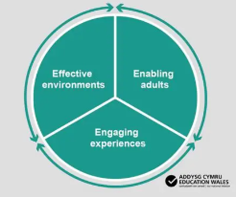

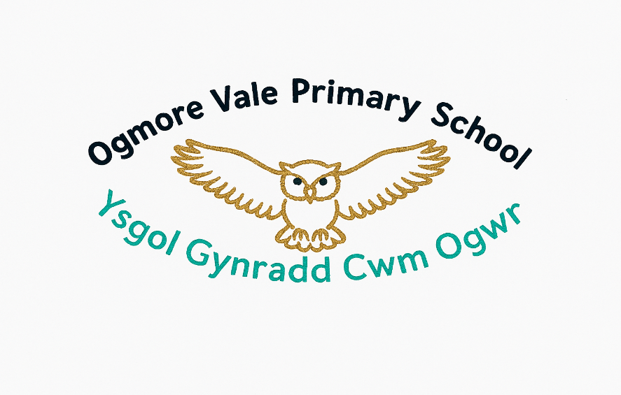
Teaching and Learning
2. To audit, adapt and refine indoor classroom environments to ensure they are effective for all learners and actively enable high-quality learning opportunities.
Lead: Mrs D Bradley/ Mrs C Hobbs

Leading and Improving
- To further develop middle level leaders ensuring the effective distribution of leadership across the school.
Lead: Mrs L Brown

School Priorities 2026-2027
Teaching and Learning
3. To further develop the teaching of mathematics and numeracy through the 5 proficiencies, ensuring the progress of all learners.
Lead: Mr C Hanford

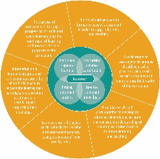
Teaching and Learning
4. To review current methods of teaching spelling and implement changes to improve standards.
Lead: Miss J Jones

