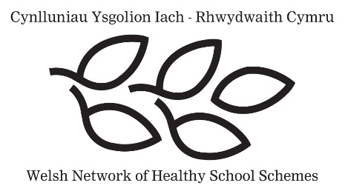
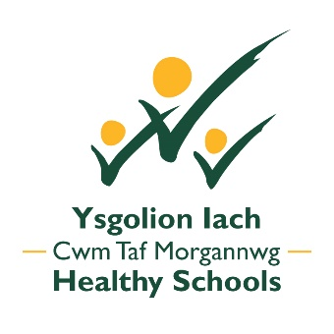
f

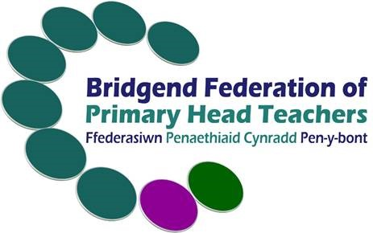
Relationships & Sexuality Education Policy

Ogmore Vale Primary School

Agreed by BCBC HT Federation Policy Group June 2023
Adopted by Ogmore vale Primary School March 2025

Written in line with Welsh Government Statutory Guidance, the RSE code and legislative summary (January 2022)

This policy has been adapted from a much longer policy template provided by Cwm Taf Morgannwg Health Board.

The Federation policy group considered the document in full and have made numerous alterations, including removing a number of sections that were felt to be unnecessary and/or inappropriate to a primary school setting.

Contents Page

 | Page number
- Introduction | 3
- Aims of RSE | 3
- What is RSE? | 3
- Legislation and guidance | 4
- RSE curriculum | 4
- Progression in RSE | 5
- Dealing with questions | 5
- RSE for Learners with Additional Learning Needs | 6
- RSE Resources | 6
- Partnerships and Engagement with Stakeholders | 6
- Monitoring and Evaluating RSE | 7

- Introduction

Ogmore Vale Primary School is committed to adopting a whole school strategic approach to high-quality provision of Relationships and Sexuality Education (RSE) for all learners. This policy has been developed in consultation with a range of stakeholders and aims to respond to the needs of all our learners and families.

“RSE has a positive and empowering role in learners’ education and plays a vital role in supporting them to realise the four purposes as part of a whole-school approach. Helping learners to form and maintain a range of relationships, all based on mutual trust and respect, is the foundation of RSE. These relationships are critical to the development of emotional well-being, resilience and empathy. An understanding of sexuality with an emphasis on rights, health, equality and equity empowers learners to understand themselves, take responsibility for their own decisions and behaviours, and form relationships that are fully inclusive, reflecting diversity and promoting respect.” (Welsh Government)

- Aims of RSE

Our RSE provision aims to:
- Have a positive and empowering role in learners’ education and is vital in supporting them to realise the Four Purposes as part of a whole-school approach.
- Support learners to form and maintain a range of relationships, all based on mutual trust and respect.
- Encourage learners to make responsible, well-informed decisions and be able to understand themselves and others.
- Equip learners to challenge harmful stereotypes and perceptions and be able to seek help and support.
- Be positive, protective and preventative, underpinned by a needs-led, rights-based approach which takes a positive view of relationships

- What is RSE?

RSE encompasses the knowledge, skills, dispositions, and values that will support learners to:
- Promote their own positive health and well-being
- Develop healthy, safe and fulfilling relationships of all kinds, including those with family and friends
- Navigate and make sense of how relationships, sex, gender, and sexuality shape their own and other people’s identities and lives
- Understand and support their rights and those of others to enjoy equitable, safe, healthy and fulfilling relationships throughout their lives and advocate for these

As part of our approach to RSE, we will:
- Provide accurate facts at an age-appropriate level.
- Use correct biological terminology.
- Promote a safe, positive, open and honest learning culture free from stigma, shame, fear and guilt which is positively inclusive, respectful and safe for all learners.
- Developing an acceptance of different attitudes and values, challenging harmful stereotypes and perception, including gender norms.
- Provide objective, supportive and inclusive information about growing up, body changes, healthy relationships and reproduction at an age-appropriate level.
- Help learners to understand the importance of equity, recognising the importance of rights in ensuring fair treatment for all.
- Uphold and develop learners understanding of the United Nations Convention of the Rights of the Child.
- Help pupils to understand change, conflicts and pressure
- Recognise potentially harmful behaviours in relationships and know how to seek support.
- Endeavour to create safe and supportive learning environments. This helps to create trust and allow learners a safe space to consider learning, ask questions and express their thoughts and feelings.

- Legislation and guidance

RSE Code (Welsh Government)
- Relationships and Sexuality Education (RSE) is a mandatory part of the new Curriculum for Wales framework for all learners from ages 3 to 16.
- Parents/carers are no longer be able to withdraw their child from RSE provision.
- Using supportive guidance, schools will design their own RSE Curriculum
- The RSE Curriculum must be developmentally appropriate for learners.
- The RSE Curriculum must include learning that develops learners’ awareness and understanding of different identities, views and values and a diversity of relationships, gender and sexuality.
- Our school policy and curriculum have been developed in line with the Equality Act 2010.

- RSE Curriculum

RSE is one of several cross-cutting themes that are woven throughout the curriculum as part of our overall provision. The RSE Curriculum will be taught using a mixture of approaches including discreet lessons where appropriate and across related Areas of Learning and Experience (AoLE), using teaching strategies and techniques which are developmentally appropriate and meet learners needs. This will also help to avoid a ‘single issue’ approach where each lesson covers a different RSE issue, isolated from other learning.

The RSE Code focuses on three broad strands:
- Relationships and identity: helping learners develop the skills they need to develop healthy, safe, and fulfilling relationships with others and helping them to make sense of their thoughts and feelings.
- Sexual health and well-being: helping learners to draw on factual sources regarding their sexual and reproductive health and well-being, allowing them to make informed decisions throughout their lives.
- Empowerment, safety and respect: helping to protect learners from all forms of discrimination, violence, abuse and neglect and enabling them to recognise unsafe or harmful relationships and situations, supporting them to recognise when, how and where to seek support and advice.

The Welsh Government is committed to covering the following themes in RSE: relationships, rights and equity, sex, gender and sexuality; bodies and body image, sexual health and well-being; violence; safety and support. These themes are interwoven into the above strands.

As part of the process of developing our school’s RSE curriculum we;
- Ensure pupil voice is reflected within our planning.
- Ensure that the content is developmentally appropriate for all learners.
- Continue to monitor and evaluate the scheme of work and the suitability of resources.
- Liaise with outside agencies, e.g health and co-ordinate their involvement with the RSE programme where appropriate.
- Liaise with parents / carers where needed regarding RSE Curriculum.

- Progression in RSE

We will always seek to ensure that our RSE Curriculum is developmentally appropriate for our learners. At Ogmore Vale Primary school we reflect upon the Phases 1 and 2 as outlined by the Welsh Government’s Code, which sets out guidance for what content is covered from a particular age upwards. In deciding at which age to introduce specific topics, we will take account of a range of factors including the learner’s age; knowledge and maturity; any additional learning needs and anticipating their physiological and emotional or social development and needs during planning. Learning within the RSE Curriculum is to be linked to the following phases:
  - Phase 1: from age 3​
  - Phase 2: from age 7​

The principles of progression across the Health and well-being AoLE offers guidance to progression in RSE. Our curriculum revisits content, themes and topics as outlined in the preceding phases set out in the Code, reinforcing, and building on learners’ developing understanding and changing needs.

Ogmore Vale Primary school seeks to provide accurate, unbiased information on RSE to learners as part of our pluralistic approach. This means that where questions of values are concerned, we would acknowledge that a range of views exist on a given subject. As they develop, learners are encouraged to take increasing responsibility for their own learning.

- Dealing with Questions

If staff are asked potentially sensitive questions by learners related to RSE, the member of staff will never disclose their personal experiences. They will use their professional judgement in providing answers which are appropriate to the age and maturity of the learner or of other learners who may be listening. There may be times when teachers feel that it would be better if pupils ask their parents/carers instead and if this happens, teachers will try to inform parents/carers. In some cases the Safeguarding Policy may need to be followed.

- RSE for Learners with Additional Learning Needs

The RSE Curriculum must be provided for learners with additional learning needs. Staff at Ogmore Vale Primary school consider how best to meet the needs of individual learners whose additional needs means that their understanding may not match their chronological age. All staff are aware of the school’s approach to RSE when working with learners with additional learning needs.

- RSE resources

We will always aim to ensure that resources use for RSE are relevant, reputable, developmentally appropriate, inclusive and sensitive to learners’ needs to support the RSE Curriculum. These resources will be reviewed over time. We will consult with parents over the resources that are intended to be used. Overviews will be shared termly from the scheme we follow to teach our RSE lessons – ‘Jigsaw’.

- Partnerships and Engagement with Stakeholders

Working with Parents / Carers
As part of the Curriculum for Wales, RSE is mandatory for all learners aged 3 – 16. This means that parents / carers can no longer withdraw their child from RSE in line with the roll-out of the curriculum in each year group. However, Ogmore Vale Primary school acknowledges that parent and carers have an important influence and role to play in terms of delivering messages about relationships and sexuality education. Parents and carers are the key people in teaching their children about sex and relationships and maintaining the culture and ethos of the family. RSE is a shared responsibility and as such schools seek to keep parents /carers informed about this RSE Policy, the RSE Curriculum, and resources where possible.

We support parents / carers in understanding why high quality, inclusive RSE at Ogmore Vale Primary school is important to the development and learning of every young person. Parents / carers are encouraged to discuss concerns they may have with their class teacher.
The school welcomes any comments from parents and carers that are aimed at improving the school’s provision in this area. In situations where parents / carers are unhappy with elements of the RSE Curriculum, they are asked to follow the school’s complaints policy.

External partnerships
Whilst Ogmore Vale Primary is responsible for the delivery of the RSE Curriculum, we recognise the value of involving appropriate external agencies/visiting speakers to complement the RSE Curriculum. This input does not substitute or replace the school/education provision and delivery of RSE. If the school/educational provision is approached by an unknown external agency/speaker, then advice regarding suitability will be sought.

- Monitoring and Evaluating RSE

This RSE policy and our chosen resources will be kept under regular review involving school staff and other stakeholders as appropriate. This would usually be undertaken every three years or sooner if necessary.

